Why use Psychology In CHildren's Marketing?

Excerpts from a speech By Dr. Langbourne Rust, Conference Chair
Kid Power Asia 2000. Singapore 9/15/200

If you want to know how to market products to children, know from the start that it is hard to do and that there are no simple answers.

Paul Kurnit, President of the Griffin Bacal advertising agency and one of the most knowledgeable practitioners of children’s marketing I know, says something like 97% of all new children’s products fail within a year or so. Kid marketing is very, very hard. Billion dollar businesses come and go overnight. Remember Levi’s? Remember Guess? I remember watching the sports trading card industry drop from $3B in US business to $1B in about a year.

There are lots of different ways to do kid marketing. Some may be right for you. Some may not. I have devoted my career to helping companies take a psychological approach to kid marketing, but I will be the first to admit that my way is not the answer to every business situation.

So I’m going to begin my talk by telling you what marketing strategies work best under different business conditions. I’ll talk about the kinds of corporate cultures and the kinds of individuals who do these different kinds of marketing best. Maybe your company should take one approach, maybe another.

And then I’ll give a taste for what a psychological approach to marketing can do by sharing with you a few of the psychological truths that I have learned over the years. These are truths that I hope will empower you provide children with better products through the medium of the marketplace.

So the question I’m going to address is not “Why” but “When?”
“When is it best to use psychology?”
Psychology won’t always help you.
It depends on what you seek, what situation you are in, and your corporate personality.

But before I give you all the answers …

Let’s talk about fishing.

I’ve done a lot of fishing in my time. And as I see it, there are some very different strategies for getting fish. For getting them to bite. For marketing to them, if you will.


Strategy #1: Sit and Wait

The first is to find a spot on the bank, drop a hook in, sit down and wait for a bite. The Sit and Wait strategy.

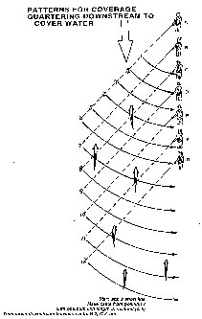
Strategy #2 - Saturation casting

The second strategy is to walk around the bank, pulling your lure through every bit of water you can reach. Saturation casting. Try everything everywhere.

Strategy #3 - Follow the crowd


The third is to find where other fishermen are and go join them.

Strategy # 4: Study the fish's mind

The fourth strategy is to study the fish’s mind. To do your own “fish psychology"

When to use each strategy

Each of those strategies is legitimate. Great catches have come from all of them. But as I see it, they are best suited to different conditions, different persons and different needs.

Bank sitting
Sitting on the bank and waiting for the fish to find you makes sense when you are fishing in a place where you caught fish before.

The drill is simple: Do what you were doing before and hope luck smiles on you. It can be a wonderful, peaceful way to spend time. You expend a minimal investment in tackle, transportation, bait or energy.

You may catch fish. But you usually will not. If that bothers you, use another strategy. If it doesn’t – then stick with this one and you may luck out.

In summary, Sit-and-Wait fishing is a strategy requiring minimal cost but carrying high risk of failure and a low expected return.

Saturation Casting
This is a great strategy when you are new to the water or don’t know the fish.

Be sure to cover all the water. Use all your lures. Fish hard. Never linger. If you get a bite, stop moving and fish the spot hard. If you don’t get a bite, don’t waste your time on a second cast. Keep moving.

This is a hit or miss business. The odds are low. You will fish over lots of empty water. But every once and a while you will stumble into a honey hole and do wonderfully well

In summary, this is a high risk, high cost strategy with a medium expected return and a very high top-end potential.

Follow the Crowd
There are a lot of times that following the crowd makes sense.
Especially when you are fishing well-fished waters where others are catching fish and you don’t know why.

You often catch at least a few fish this way – at least when other people are catching them, and at least when you imitate the successful fishermen as closely as you can.
Of course you’ll probably catch less than the leaders. And your success depends a lot on picking the right crowd. They might be wrong about the fish, too.

In business terms, this is a strategy with lower risk, medium cost medium return and a somewhat top-side potential

Study the fish
And there are times when it pays off to do the science: to learn what fish need and how they perceive things. It requires that you think before each cast, remember what you did, and keep looking for the underlying patterns or principles. But once you've done this, you can go off and fish where others are not fishing. And you will catch more fish, bigger fish, and more consistently than anyone else.

This is a medium-to-high-cost strategy, especially in terms of time, but it carries lower risks of failure, and holds out the promise of higher returns, than the others.

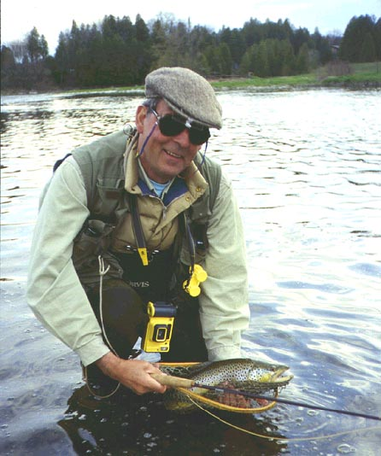

It works

And so it is in marketing

For selling into familiar markets when you have limited resources:
Drop your bait in the water. Sit and wait … you may luck out.

For new markets; where you can tolerate failure; have deep pockets and have lots of time:
Blind Cast everywhere. If you do it enough, you’ll eventually get some hits.

Where you are selling into established, mature markets and where you can not accept failure:
Find the market leaders, follow them, and stay in heavily fished water … you’ll bring something home

When you are trying to move into brand new markets and where failure is not acceptable:
This is the time to study the consumer’s mind. Do the psychology and find consumers where no marketers have gone before.

Psychology gives marketers an edge when they are striking out to new waters: new products, new media, or new consumer segments.

Different kinds of marketing people
As I see it, each kind of marketing takes a different kind of person.

Sit and Waiters
Sit and Wait marketers need boundless optimism, and lots of patience.
It helps to either be very rich – and able to absorb your losses – or very poor, with nothing to lose.



I saw lots of these kinds of marketers on Sunday here in Singapore. The put their bait in the water and sat waiting for a hungry consumer to swim by.

Saturaters
Saturation marketers take an active approach to getting sales. They keep casting. Again and again and again. They try to make a pitch at every consumer with every product. If they don’t get a hit immediately, they move on to a new one.



Here was a toy salesman I saw yesterday. He never stopped. He had incredible focus and energy. He’d try out one toy after another on each customer. But if he saw a customer show signs of fading, he’d spin on his heel and try another.

Crowd followers
I’ve met a lot of crowd followers in the corporate marketing world. My guess is that people who like to have everybody like them are especially drawn to this as a career. Many of the really good ones are very sociable, cool, and appearance-conscious. They have a great need to need to feel they fit in with the crowd. They also tend to be cautious and somewhat reluctant to stick their necks out. These are just the people to hire if you want to do marketing in markets that are already well developed. These are the people who will be really good at doing what the market leaders are doing. And they will be happy doing it.
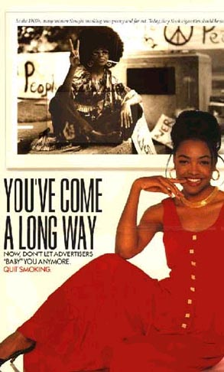

I don’t know the people who made this anti-smoking ad. But they were clearly crowd followers – copying a cigarette makers successful campaign, and making an appeal to the crowd-following motivations they assume all kids are driven by. As it is, they got it seriously wrong. In the research I did with teens on this poster, most teens thought the hippie-looking smoker in the small frame was the genuine individual, and wanted to be more like her.

Psychological marketers
Psychological marketers are harder to characterize – perhaps because there are fewer of them, and they tend not to gather in large flocks.

On the whole, they are more likely to be independent observers of the passing scene. Even loners. With a tendency to be analytical, a need to understand and hungry for new insights about other people.

I’ve known a few of them – Children’s Television Workshop was that way in its early years. Disney Records had a president who worked this way. I’ve known a few in the consumer insights departments of medium-sized advertisers. Not surprisingly, these are the marketers who look for the kinds of work I do – the ones who have been my most regular clients. In most cases, they consist of isolated groups of reflective people who have been given the challenge to reach out to new markets with new product categories, and who want to learn what they can before they act.

That’s what I’m here for today. To help you learn about this forever-new, ever-changing market category of children.

What is special about kids marketing?

Kids are a special case for marketers.
Their minds are different.
They live in different worlds.
They require special care and protection.
We can't run risks with unintended side effects of our marketing efforts.

Not many marketers understand kids - that's why they follow conventions
Most of our marketing comes from blind-trial-and-error saturation selling, or unconsidered crowd-following. All too little of it comes from an understanding of the broader truths of children. The broader truths, I believe, can empower the marketer who takes them seriously. Let me give you some examples.

Psychology can break conventions
A lot of the principles of children’s marketing that you hear these days are wrong - some are dead wrong, some are partly wrong, and many are just woefully incomplete

But there is a silver lining. Because most advertisers, most of your competitors, are bunching up on the same few images, the same few themes, the same few strategies. And there are many directions you can go in to get to open field and be freed to do things no one else is doing - stuff that really works.

There are lots of popular beliefs about how to market to children. Some are wrong. Some are right. Most are just part right. Here are some you may have heard

Different campaigns for different ages.
Kids supposedly change so much every couple years that you really should have a different campaign for each age.
The most-liked product wins.
If this is true, you should find out what they like and make it, or find a way to make them like what you've got.
Kids want, parents control.
If this is how consumers work, you need to find ways to get kids to crave your product and ways to disarm the gatekeeper.
Kids want cool.
So make your product and advertising cool and trendy.
Kids want hot.
Presumably, today's kids are a lot more mature and more media sophisticated than earlier generations, so use the hottest, newest, edgiest ads you can get away with.
Kids want to be older

More kids will watch boys

etc. etc - the talk covers some other prevalent beliefs & then goes into 1) the deeper truths behind a few of them (like "use violence" and "make a cartoon" )and 2) how knowing deeper truths lets you do things successfully in ways that no one else is using. I give examples of marketing successes that broke with the conventional wisdoms, but held onto larger truths - like Nickelodeon's Rugrats & Clarissa

