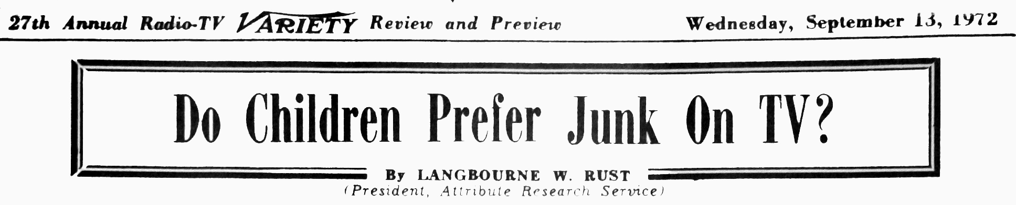

At times one gets the impression that there are only two kinds of children's television: quality material and junk, and that children prefer the junk, Nearly all attempts quality programming, no how much they have appeal to adults, have failed to achieve sizable audiences of children. ‘Make A Wish “Take a Giant Step” and “You Are There” were all launched by the networks as quality children’s programs and they all came out second best to the cartoons
A series of studies I did recently for Children's Television Workshop demonstrated that children do not like junk for its own sake. These studies were made possible by two new research techniques: one for identifying the qualities of that material to which they really respond. The studies showed that despite the experience of broadcasters, children like quality material if it is geared to their tastes.
The problem is that producers of both quality material and junk have had an unclear picture of children’s real preferences. ‘ When they arrived at rules-of-thumb or formulas which worked fairly consistently for them, they were apt to accept them as true reflections of what children like. Un fortunately, in so doing, they closed themselves off from a potentially broader understanding of children’s tastes, and they had little to go on when they tried to produce material that broke away from conventional molds.
Traditional Components
Four attributes typically embodied in quality programs illustrate my point:
(1) Children’s programming is typically done in short segments or scenes with little subject development. The rule of thumb behind this trend is that children have short attention spans. “The Electric Company” and "Sesame Street” were built around this assumption, and most cartoons and adventure shows evidence similar thinking.
(2) Cartoons are by far the most favored program format for children. Animation is felt to have intrinsic appeal to children, and the more cartoon-like the production, the more child-appropriate it is felt to be. Of the 22 network shows playing between 8 a.m. on Saturday mornings, in all periods the cartoons drew more young viewers than the competing non-cartoon shows.
(3) Stupid-looking-sounding-and-acting characters are dominant in a wide variety of programs from "Sesame Street’s” Big Bird to Deputy Dawg, Scooby Doo and Jughead. Perhaps it is felt that children think like stupid adults, or that they like to feel superior to the characters, or that they identify with people who make “childish" mistakes Whatever the reason, stupid characters have become a tradition in the field.
(4) Violence in its many forms has been another traditional component of children’s television. Because of its harmful social effects, fewer violent programs are being broadcast now, but the belief that children are attracted to violence for its own sake persists, and seems to be held by both the attackers and the defenders of its use.
Puncturing The Myths
Each of these suppositions about what children like has an element of truth. My research has shown that children tend to be attracted to material that has these features. But the fact that children often enjoy such material does not mean that these are the features that attract them. The Children’s Television Workshop research gives a more accurate picture of what children respond to.
Strictly speaking, children do not have short attention spans. They are able to concentrate for long periods on material they find interesting. They do not automatically “tune out" after an interval. But children are easily distracted, and they are very active. While they might sit through the first five minutes of “Face the Nation,” they are not apt to last a full half hour. Long dull material is worse than short dull material, but length as such does not contribute to dull-ness. In none of my studies has the length of a scene been found to reduce its attractiveness.
Animation appears to have no appeal of its own. In another study for Children’s Television Workshop, I demonstrated that cartoon material tends to be attractive because of the way in which animation generally demands the plot or theme to be developed: through active physical movement or locomotion through space. Children respond to this kind of functional action wherever it occurs. They are attracted by It as much in non animated material as in cartoons. Furthermore, animated material that does not have this attribute of functional action is not attractive to children.
Children are not attracted to stupid characters because of their stupidity. What children do like is to see correct and incorrect activities and solutions – all clearly portrayed and labeled. What is right and what is wrong is interesting and any material that clearly embodies such a theme will at tract their attention. ‘Big Bird’s bloopers will continue to engage pre-schoolers so long as Bob or Gordon or Mr. Hooper are there to point out the goof and show what is right. Children are also attracted by themes of repeated attempts to achieve or surpass a standard, but failure and stupidity are not necessary conditions to attract them. Two people scrambling to climb over a wall are as attention-getting when they both succeed as when they both fail.
Chase-Appeal
Violence may not be attractive to children. Two attributes which have been consistently found to attract children are often present in violent scenes, and they may be the features that really attract children. The first is the theme of catching-chasing-fleeing-getting caught, etc. The second is the quality of functional action which was discussed above. Violent scenes usually possess at least one of these attributes and often they possess both. Children like the endless chases in shows like “Superman,” and they attend closely to the fights which are so frequently integral the plot development. But other active conclusions to chase scenes are possible. The winner of a race does not have to stomp the loser to make the race, or its conclusion, exciting. Getting chased by someone else is just as interesting.
More study will have to be done before it can be asserted that these two qualities, or related qualities, are at the root of children’s fascination with violent programs. Violence for its own sake actually may be unattractive to children. Functionally active chase scenes may be more appealing when they do not include, compnents of personal violeace, injury and humiliation.
Forcing Change
The research results do not dispute the practical value of the rules-of-thumb. Producers who continue to turn out cartoons featuring violence and stupid characters and which have little or no subject development will continue to attract children so long as they are permitted to do so. But the force of public opinion is going against them, and they may soon be compelled to search for new ways to attract children or to abandon children’s programming entirely.
The research 1 have done points out what some of these new ways might be. It suggests that producers can make quality programs which will be as consistently successful as the traditional fare has ever been. When producers become convinced that children like quality programming better than junk, and when they see that they can make such programs economically, they will take- the initiative to upgrade children’s television.

