Children’s Advertising and Purchase Behavior

by Langbourne Rust, President
Langbourne Rust Research, Inc.

Speech to the Advertising Research Foundation
Children’s and Teen’s Workshop
June 17, 1996

Table of Contents
KidWatch 2
Findings: Non predictors 4
Familiarity 5
Product appeal 6
Copy-related questions 11
The ARF Copy Research Validity Project. 11
Program context 12
Perceived mom opinion 12
Shopping circumstance. 12
Whom to target 13
The in-store experience of a child. 14
Priming kids’ perceptions 16

I set out a number of years ago to find out what I could about how advertising works with kids - psychologically - and in particular how it changes their actual behavior as consumers.

This paper describes the data I’ve been collecting on children, on how they react to ads, and how they ask their parents for products in everyday life. There are a number of factors which had been expected to predict purchasing behavior, but did not. And among the factors that did predict successfully, some came as a bit of a surprise. All of these findings, both positive and negative, have practical implications for those of us who create or evaluate children’s advertising.

KidWatch

The data on advertising came from KidWatch - a TV advertising copy test system that was developed a number of years ago, specifically for children’s advertisers. Like most commercial copytesting services being offered today, kids are recruited to come in and watch a TV show with ads in it.

The system uses a camouflaged design. It is important that children view their experience as being centered on entertainment programming - not ads - so that their responses will be more typical of real-world viewing. The test experience is set it up so that the kids don’t feel they have to focus their attention on what we are showing them. But while they watch, we videotape their faces, to see what parts they actually attend to.

The room is set up differently than most test rooms. Rather than having a single TV set with a kid plopped down directly in front of it, there are 2 TV sets and the child is free to watch either one.

On one TV, the program plays, with the test and some clutter ads within it. On the other TV, there is a series of still slides - with pictures from a random assortment of children’s programs, and no audio track. It is pretty boring, but if kids are uninvolved with the test tape, they look over at it. The camera that videotapes their faces is mounted behind a screen placed between the TV sets.

Sometimes they watch. Sometimes they don’t. Both of these girls were taped watching a commercial for a Barbie shower set. The TV set with the commercial is on the left. The distractor TV with the slides is on the right. One of the girls asked her mother to buy the product for her when she got home. Guess which one.




Like other copytest systems, KidWatch follows the viewing session with an interview in which, through a series of standardized and open-ended questions, gets measures of:

- Brand appeal
- Ad appeal
- Recall
- Key point communications.

This is where most systems end their field work, and until a few years ago, so did KidWatch. Then a new component was added, as an experiment.

Purchase requests
A week after the survey, a telephone call was placed to the home of every child who came to the copytest, and the interviewer asked to speak with the mom. She was asked whether, in the week since the survey, her child had asked her to buy any products in the test category, and specifically, whether the child had asked for the test brand.

This was done to find out what happens in the real world. Do the things children say in an forced interview, after an artificial viewing experience, give a true picture of how they would behave in everyday life? If not, the whole testing industry, and with it a lot of modern marketing, is on very shaky ground.

The data for the current analyses were from copytests of 41 ads, all of them for food products of one sort or another, such as desserts, snacks, frozen novelties and breakfast cereals. The total sample was 5,533 kids between the ages of 6 and 12.

Findings: Non predictors

Although some factors predicted which kids would ask for a product, some did not.

I can’t tell you how often I have tested ads which had been created to communicate some physical attribute of a product: that it is sweet or crunchy or round or big or shaped like an animal, etc. And many of the ads succeeded at communicating their point very well. But the problem was that getting the point didn’t increase requests for the product. The ads succeeded vis a vis the strategy, but the strategy was wrong.

Lesson #1: Don’t try to communicate attributes.

Even if kids understand what a particular attribute is, and even if they say, when you interview them, that this is the attribute they like in their favorite brand, when it comes to really wanting something and asking mom to get it for them, they do not use their attribute knowledge at all.

For kids, the analytical syllogism doesn’t work:
“This is my favorite. This is its key attribute. And this other product has the same attribute. Therefore I will like it, too.”
It would be nice if they did, but they don’t. For most kids, thinking goes more like
“This is my favorite. I don’t know that one. I’ll stick with what I know.”
You might point out to them:
“But they have the same attribute!”
And their response is likely to be,
“Sure, but so what?”

Findings: Successful predictors

Familiarity
Kids are more likely to ask for a product if they have had it before. The scores in the following table are indexed to a mean of 100. Kids who had had a product before indexed at 18 points higher than those who had not.

Familiarity factors which predict asking

asking index
History
Had the product before 106
Not had it before 88
Product recency
Recent (past year) 136
Old 103
New 67

How recently the product was introduced also makes a difference. Established products clearly have an edge, and those that are old, but not too old, have the highest request rates of all. The low asking rate for brand new products is worth contemplating. It is not easy being new in a kids market.

Lesson #2: Kids are drawn to what they know

Kids are inherently conservative. They are drawn to what they know and they avoid what they don’t know. It is clear that new products have high hurdles. And I don’t know any way to run around them. You can’t become a “recent” product without going through a phase as a new product first. So the first task of a new product is to build familiarity. The second task is to stay fresh for as long as possible.

Product appeal
There are lots of different ways to measure product appeal. KidWatch uses three. The first is a very conventional question, an adaptation from adult testing.

The star scale, and its close cousin the smiley scale, are the war-horses of the kid testing business. Kids use the star scale to indicate how much they like a product, The bigger the star, the more they like it, the smaller the star, the less they like it. The conventional way to score them is to sum the top-2 boxes.

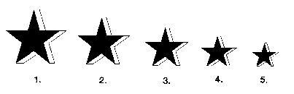

The “tastes great” question differs importantly from the star scale in that it is framed as a “Yes/No” question:

Do you think that Product X tastes great?
Yes, No or Not Sure

Picture pointing. In the third kind of product appeal question , children are given a sheet of paper with the picture of 6 or 8 products on it and asked to point at all the ones they wanted.

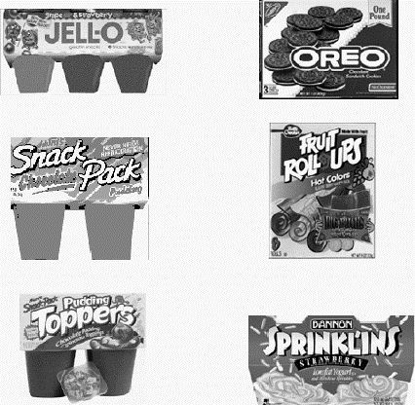

Table 2: Product desire questions which predict asking

asking index

Picture pointing 120
Tastes great (yes/no/unsure) 119
Star scale (top 2 box) 119

The good news about these measures is that they all predict asking - and at about the same levels, in the aggregate. But the bad news is there are some serious age anomalies, particularly the star scale.

Star Scale versus Ask Mom scores, by age

The Star Scale has real problems with children under age nine. As the graph shows, the number of kids who actually asked their moms for the advertised products dropped only slightly with age, between the ages of 6 and 12. This gives a pretty good indication of the underlying appeal of the products: they decline gradually with age. But what happens with star-scale ratings is notable. Between the ages of 6 and 9, there is a dramatic gap between top-box star scores and the behavioral measure of appeal.

The way children use the rating scale changes radically with age. I would frame the lesson a little more broadly, and suggest you stay away from all multi-point rating scales with the younger age segments.

Lesson #3 Avoid multi-point scales below the age of 9.

The tastes great measure was a yes/no question, not a dimensional scaling. Cognitively, this is a lot simpler question to understand. And as the graph shows, its performance was a lot more stable across the ages. Whereas the star scale dropped 42 points between age 6 and 12, the yes/no question dropped 23.

Lesson #4: Yes/No questions have less age bias than dimensional ratings.

Tastes Great versus Ask Mom Scores by Age

The third type of question, picture pointing, was even more concrete. Rather than asking kids to make judgments - about degree of likability in the case of the star scale or about the existence of good taste in the other - it just asked children to point to things they wanted. And now, the age-bias problem dwindles to insignificance. The net drop between age 6 and age 12 is only 13 points, and the trend very closely parallels the baseline trend in product-request frequency.

Lesson #5: Product-pointing is a measure that works for all ages.

This should not be too surprising, when you think about the mental processes that are required to do the picture picking and the mental processes that are used by kids in the store. The are the same. Kids see an array of products, and point at the ones they want. I believe this to be part of a more general truth: namely that where kids are involved:

Lesson #6: Behavior predicts behavior better than thinking does.

Copy-related questions
While questions about the product predict which kids will ask their parents to buy that product, so did some questions about the copy itself.

Ad likability: Kids who like an ad are more likely to ask for the product that it promotes.
Recall. Some kinds of recall are also predictive: Kids who remember something about the story of an ad, or remember having seen an ad for the test product, are more likely to ask for it, too.

Copy-related factors that predict asking

asking
index

Ad is fun to watch 119
Recall
Nothing about ad 79
Brand name 106

The ARF Copy Research Validity Project.
These findings echo the results of the ARF’s study of adult copytest systems which was done in the early 90’s. This was a massive experimental study that tested different design elements against sales volume using highly-controlled, split-cable markets.
It’s key conclusions were much the same as we found here:....

* Copytesting works
* A variety of measures predict market success, and
* Ad likability, brand recall and product likability are all significant predictors.

But the current study was not done just to find the best copytest questions. It was done to find out more about how ads work, and how they impact kids in the real world. Three other factors give insights into this subject, all of them factors of experience that reach beyond the solitary child with the solitary commercial.

Appeal of program context predicts asking
asking index
Kid likes the TV show (a lot) 119

Kids who like the show in which an ad is placed are significantly more likely to ask for the advertised product. By extension, it seems that media buys get advertisers more than people-counts. Well-liked kids programs apparently make the ads themselves work better.

Lesson #7: Media buys can get you more than people counts.

Perceived mom opinion predicts asking
asking index
Mom likes the product 121

Kids who report that their moms like a brand are much more likely to ask for it than kids who say “no” or aren’t sure. It appears that, at least where food products are concerned, mom’s opinions matter, and so do kids’ perceptions of what mom’s opinions are. So don’t ignore mom in your advertising, and you might think of ways of reassuring kids about mom’s acceptance of your product.

Lesson #8: Mom’s attitude matters to the kid.

This factor is worth paying attention to, but the next one may well be the most important one of all.

Shopping circumstances affect asking.
Kids are significantly more likely to ask for a product if their moms go grocery shopping. And those who go shopping with her are overwhelmingly more likely to ask for it. A kid who goes shopping with mom in the week after seeing an ad in a copytest is almost 4 times as likely to ask her to buy the advertised product as the kid who stays home.

When mom shops....
if the child goes with her 40% ask for the advertised product

if the child stays home 11% ask for it
Asking for advertised products

Lesson #9: If you want your ads to work, get kids into the stores.

These ads worked by triggering something that happened in the store. If kids didn’t go shopping, not much happened.

If kids’ ads work as triggers, they should have special power if they are integrated with packaging and other point of purchase stimuli. So make your ads so that they trigger recognition or otherwise reinforce the in-store experience.

Don’t do as one client of mine did. They developed a strong TV campaign with distinctive characters and icons but never printed the images on the packaging in the store. Kids liked the ads, recalled the brand and liked the product. But when they got to the store, the icons weren’t there. And nothing happened.

Who to target
If ads work strongest on kids who go shopping, then it makes sense to identify the most-likely shoppers. You should make a special effort to reach out to the kids who are most likely to translate your advertising dollars into purchase requests. In the case of foods, this is likely to be girls and younger kids.

Lesson 10: Reach out to the kids who shop.

Demographics of askers
asking index

Girls 109
Children under 9 110

The in-store experience of a child.
When young children enter a well-stocked store, they find themselves in a quandary. There is so much stimulus, there are so many unknown options, that they are easily overwhelmed. Children are more vulnerable than adults, because they don’t have the cognitive tools for comparing, analyzing and deciding between alternatives. That is the reason, for example, that the star scale worked so poorly with kids under 9.

Here is a shelf of breakfast cereals at my local health food emporium, in Briarcliff, New York. Mostly twigs and leaves, I guess, but some are in fancy packages.

Health Food Cereals

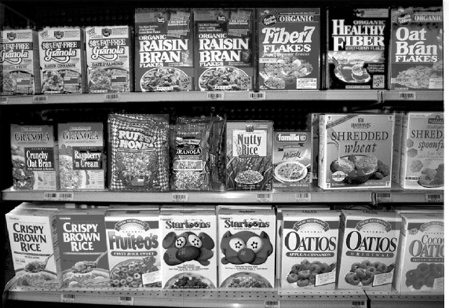

Familia Cereal



Here is the only health cereal my family ever gets. Familia. We get it when we go backpacking. It gets real mushy real fast, and tastes kind of powdery, but it packs a lot of nutrition and you can eat it just with water, so it is convenient for campers who stay in the woods longer than milk stays fresh.

You might not have noticed it in the previous picture. But it was there. Look back at Figure 1. It is the smallest, and least graphic box on the shelf. But somehow, having learned what it is and having seen it so recently, it jumps out in front (even more so if you see its distinctive green color).

That is the way TV ads work for kids when they get to the store. I said nothing particularly attractive about Familia. Quite the reverse. But this kind of advertising doesn’t work by persuasion. It works by getting kids to notice products they otherwise would have missed. It gets them to set their crosshairs on a product, and when kids focus on something, the rest of the world disappears - even the competition right next to it on the shelf.

Zeroing in

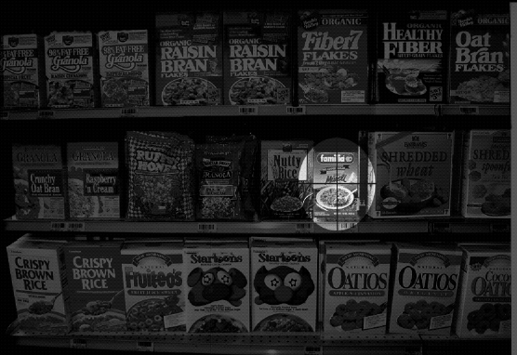

Priming kids’ perceptions
A lot of children’s advertising does what I call “Perceptual Priming.” These commercials don’t change kids’ minds, and they don’t persuade them to make certain decisions. They prime kids’ perceptions. They set up their aiming mechanisms, so that when they get into the store, recognition is triggered, and that, in turn, triggers targeting, pointing, and, ultimately, purchase requests.

Without the ad, the product would be lost in a blur. With the ad, it jumps out and grabs them. They lock their sights on it and zero in. But none of it happens unless they are in the store.

Kids ads most often work by making things happen in the store. If you keep that in mind, you will know how to make better ads, you will look for ways to get more kids into the stores, and you will stimulate a lot more purchase requests.

